Field Exercise and Data Entry

We are going to practice using the AKN for a field exercise. We will practice 1) uploading sampling units for the exercise into the project, 2) entering data collected in the field under those sampling units and then 3) examining the data in the Analyst tool.

**Field Exercise:**

We will divide up into groups to do surveys along different point count transects. Each group will have a different study area, but everyone will collect their own data on their own datasheet and then enter it into their own transect they create within the AKN.

We will be doing standard point count surveys using a 6-minute protocol similar to the point count protocol used for Pinyon Jays at WSMR. You will be surveying for all species you see or hear at each point. Divide your observations into 1-minute time bins and record the number of birds and the detection type (audio or visual) within the distance bin they occur (distances bins on your datasheet occur in 100m intervals). If you observe any behaviors, you may also record behavior codes (optional). An example datasheet is below.

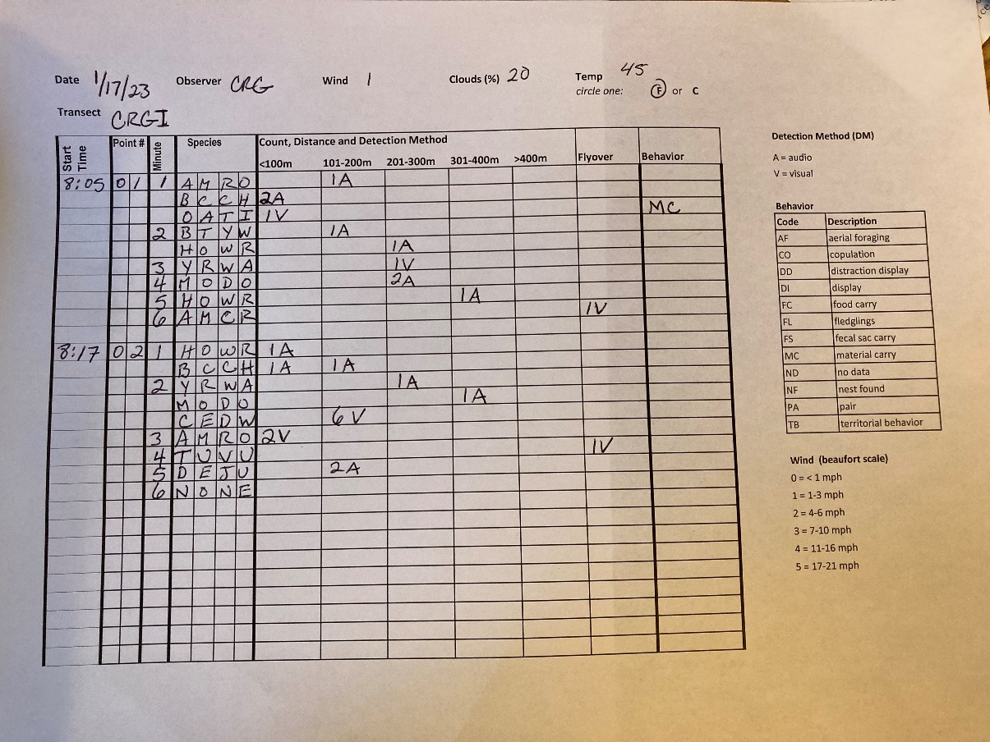

**Step 1: Create Sampling Units**

You will be collecting point count data at a series of points along a transect that you will create in the project DOD_DEMO. In order to enter data, you will need to first create the transect and points within the project. We will be grouping all the transects for this exercise under a single study area so that we can easily examine the data in the analyst tool later. You’ll want to create a new point count transect with 5 point count points nested under it.

Point Count Transect Name _________ (enter your initials plus your group letter, e.g. “MEFA”)

Point Count Point Names: __________ __________ __________ ___________ ___________

(enter same 3-5 letters as above, and append with a single digit number to create a name for five points, such as “MEFA1”, “MEFA2”, “MEFA3”, “MEFA4”, “MEFA5”)

**Download KML File with Coordinates**

1. Open Biologists (https://data.pointblue.org/science/biologists/) and log in if needed.
2. Click on “**Download Locations to GPS, GIS and more**” in the list on the right.
3. Select the project on the left DOD_DEMO
4. The screen will open in the Project Leader application. On the left side, you’ll see a list of Study Areas (most of these are service branches). Click on the ‘**+**’ to expand the sampling units next in the **WSMR_Field_Exercise** study area.
5. Find your transect group (A,B,C,D, or E) and click on the box to select the transect (it will also select the points).
6. Click on the “**Google Earth File**” button under “Download selected Sampling Units as…” on the right side. It will download a .kml file. Rename this file as something that makes sense to you and save it to your desktop (or somewhere you can find it again).

**Create Sampling Units from a KML File**

1. In Project Leader, under the Sampling Units menu bar, click on “**Create and Manage**”
2. Select the project on the left DOD_DEMO
3. Find the “**WSMR_Field_Exercise**” Sampling Area and click on it to highlight it.
4. Once highlighted yellow, click on the “**online form**” button under “Add sampling units …” on the right side.
5. In the list on the next page, under Type of sampling units, check **Point Count Transect** and click the orange “**enter**” button.
6. Fill in the information about your Transect
   1. Create a name for this sampling unit: enter the Point Count Transect Name you entered at the top of the page.
   2. Give this sampling unit a short name: enter the Point Count Transect Name again.
   3. Skip the other fields for now, and click save.
7. You should see your new Point Count Transect on the left. Click to highlight the transect you just entered.
8. Click on the “**KML File**” button under “Add sampling units…” on the right side.
   1. On the next page, click on ***Browse...*** to locate the KML file you downloaded and saved
   2. Under “**Type(s) of sampling unit**” check the box next to “Point Count Point (Point)” (this is the only option)
   3. In the box labeled “**Prefix for each Long Name”** type your initials (e.g. “MEF”)
   4. Click on “**Next**”
9. On the right hand side, you’ll see a list of points, labeled with your initials as a prefix to each (e.g. MEFA1, MEFA2, etc). Hold down shift to select all five points on your transect, and then click the **“Select”** button. The points should appear in the box on the left.
10. Click on the **“Process”** button. It will take you back to the Sampling Units page, where you should see the points now listed underneath your transect.

**Step 2. Enter Data you collected in your point count transect**

1. Open Biologists (https://data.pointblue.org/science/biologists/) and log in if needed.
2. Select the project on the left DOD_DEMO
3. Click on “**Point Count Surveys**” in the list on the right.
4. Find the Transect you created in Step 1 and click on it.
5. Under “Create a new visit”, select the protocols we used for the field exercise (note: the point count protocol is different than the one we used in Exercise 2):
   1. Observation Protocol: VRPC_6m_6db
   2. Site Condition Protocol: WEATHER
   3. c. Click the Start button.
6. Fill out the screen using the information on your data sheet.
   1. Date
   2. Visit
   3. Data sharing level - set to RAW and cannot be changed.
   4. Observer - you will see everyone in the project (all those in the class) can be selected.
   5. Start time - when did your each point survey start? Note the End Time automatically is populated
   6. Site conditions – Enter Wind, Clouds, and Temperature that you recorded at the start of your transect
   7. Observations –
      1. Search the species database - click to look up species by scientific name, common name, or 4 letter code
      2. Point - select the point you created. Notice the time is filled in.
      3. Time Bin—enter the minute number of your observation (1,2,3,4,5,6). Note the “Time” field automatically updates when you enter the time bin.
      4. Species - we enter using 4 letter codes - IBP/AOU list + unknowns + common uncertain ids. Also some mammals. You can also enter species code “NONE” if the minute you recorded data did not have any new observations. (Enter 0 as the count in the first distance bin if this is the case.)
      5. Distance bins - enter Count and Detection together as collected on datasheet.
      6. Behaviors—if you recorded a behavior associated with the observation, record the code in this field as listed on the datasheet, otherwise leave it blank.
   8. Click Save to Database when finished.
      1. If you made any errors or forgot to fill in a required field, you will get a red message at the top of the screen. Go correct the error and click the Save to Database button again.
      2. If you are successful you should see a green message at the top of the screen.
   9. After saving to the database, you will be taken to the proofing page. You can review what entered to make sure you didn’t make mistakes. It’s particularly useful to check the species list at the bottom (it will list the common and scientific names for all the species you entered on the survey ) to make sure you recorded the correct species codes.
      1. If you find a mistake, you can double click on the field and edit the field to correct.
      2. Click the Add more button if you forgot to add a line, such as an entire species, to the event.
   10. When you are satisfied, click the Proofing Completed button near the top of the page.
   11. Your survey is complete. You will see your survey in the list of surveys, and the Data Sharing Level is set to CLEAN.

**Step 3: (Tomorrow) Examine your data using the Analyst tool**

1. Log into the AKN as an Analyst. <https://data.pointblue.org/apps/analysts/>
2. The next page asks you to select the type of data you will be analyzing. Click on “Point Counts”
3. Select the project DOD_DEMO and click the orange “Next” button.
   1. (Note that if you have more than one project, you can analyze data for multiple projects at once. Hold down the control button to select more than one project).
4. At the top you will see “Groups”, this does not apply to this project and can be left blank.
5. Under Step 2, select the sampling units you would like to analyze.
   1. Find your transect under the WSMR_Field_Exercise project and check the box next to your transect name. If you click on the ‘+’ to expand the menu, you’ll notice that it will automatically select all the points that are nested under your transect.
   2. If the project contains a large amount of data not all tools will run, if this occurs you can limit your data by selecting a lower level of sampling unit (or changing other criteria).
6. Step 3 choose the criteria you would like to analyze.
   1. Date: In this case can be left as “Earliest” to “Latest” because we only have one observation.
   2. Distance: Use the dropdown box to change distance to “All Distances”
   3. Flyovers: The default is set to exclude flyovers, but you can choose to include flyovers if you want to.
   4. Visits: Default is set to All Visits
   5. You can leave the Select Groups blank.
   6. Select either All Species or the species you would like to analyze, you can select more than one by holding the Shift key.
   7. Select the type of Analysis you would like to run.

**Types of Analyses**

**Summary Information**

This is a great way to quickly summarize data and effort. This analysis provides tables for number of visits, observations, and species by month and year. As well as provides a table of richness, diversity, dominance and evenness indices for all locations selected.

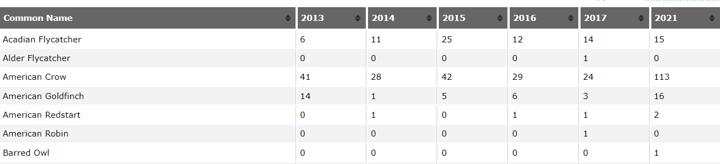

Example of number of observation of species by year.

**Diversity and Abundance**

This tool summarizes density estimates by transect in a graph and table format, as well as provides a simple linear trend analysis on density and a trend analysis on abundance.

This tool works best with limit species selected, it starts to run slowly with too much data.

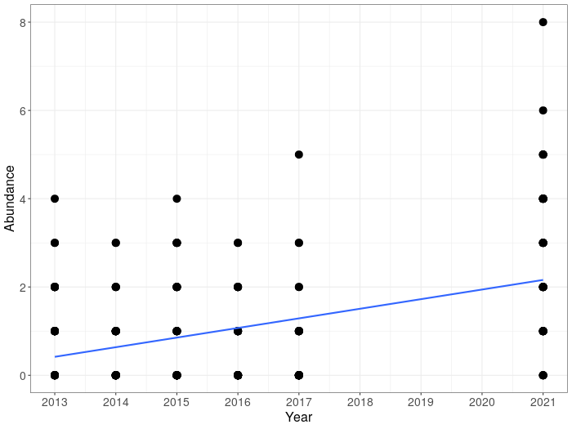

Example of trends in abundance over years.

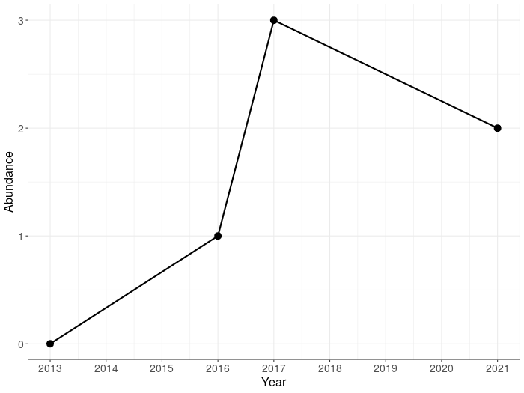

Example point level estimate of abundance for AMCR.

**Species Richness**

This analysis provides point-level mean species richness estimate for each transect in the table and graph format as well as a linear trend analysis on point-level mean species richness estimate by year.