Exercise 2: Enter Point Count Observations

**Purpose:** The purpose of this exercise is to learn how to enter survey data, including site conditions, in the Biologists tool. Steps include creating a sampling event, entering observation and site condition data, and proofing the data.

**Thinking Ahead:** Once the data is entered in Biologists and the proofing step has been completed, the data will be marked Clean. Data that is marked Clean will load into the data warehouse overnight, making it available in analysis tools such as Analysts and Data Downloader. AKN Users who collect data, but aren’t project leaders, can be granted access to the Biologists application to enter and proof their own data at the conclusion of each survey. Project leaders are responsible for granting access to the project, adding the correct Observation and Site Condition protocols to the project, and setting up sampling units.

**Glossary:**

**Sampling Event** –Represents the survey itself with a unique combination of location, date and time, person/people, and the protocol employed.

**Sampling Observation** –Observations made at a sampling event; these observations will differ depending on the specific AKN Observation Protocol being used but will contain some core fields such as species and count.

**Site Condition**: Site conditions capture covariates at a Sampling Unit at a given date and time. Site condition fields apply to the entire sampling event, not just a single observation or record and can include fields such as weather conditions, vegetation cover, disturbance, percentage of colony surveyed, and species lists. Site condition protocols define all of the site condition fields collected, including how they are organized in the user interface. Site conditions protocols can be applied to multiple projects if desired.

**Goal:** Enter the sample data and site conditions for the point count point sampling unit you created in Exercise 1, save it to the database, and complete the proofing step.

1. 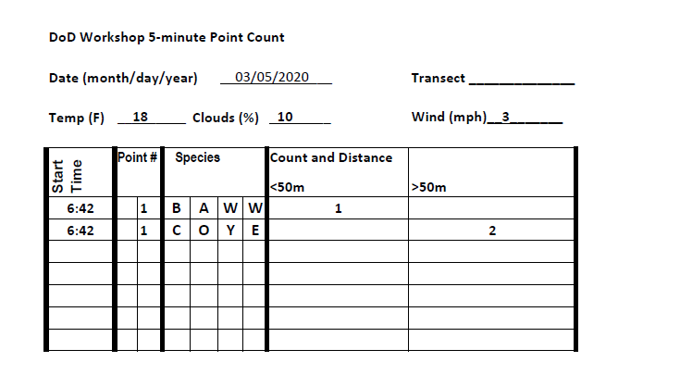Navigate to the Biologist application. Go to the **DoD AKN Portal** ([dodakn.org](http://dodakn.org)). Click on the “**Manage Data Now**” button on the home screen. Scroll down to the heading “Get Data In” and click on the **Biologists** application (<https://data.pointblue.org/science/biologists/>). Log in if needed.
2. Select the project on the left **DOD_DEMO**
3. Click on “**Point Count Surveys**” in the list on the right, under “Project Observation Types”
4. Find your service branch and the transect you created in Exercise 1 and click on it. (Note: if there is a long list, you can search the list by using “CTRL+F” to search for and find your transect name quickly).
5. Under “Create a new visit”, select the protocols we added to the project:
   1. Observation Protocol: **5m50M+**
   2. Site condition Protocol: **WEATHER**
   3. Click the **Start** button.
6. Under “General”, fill out the section using the information in the data sheet above:
   1. Date – (Use the calendar to select a date; or enter month, day, and year in any format. It will automatically be converted to yyyy-mm-dd).
   2. Visit (1)
   3. Data sharing level - set to RAW and cannot be changed.
   4. Observer - you will see everyone in the project can be selected. For this exercise, select yourself.
7. Under “Points Surveyed”, check the box next to your point (this should be the only point listed), and fill out the Start Time. Note the End Time automatically is populated
8. Under “Site conditions” , enter your observations from the top of the form.
9. Under “Observations”, enter your data.
   1. Point - select the point you created. Notice the time is filled in.
   2. Species - we enter using 4 letter codes - IBP/AOU list + unknowns + common uncertain ids. Also some mammals. If you do not know the species code, click the **Search the species database** link above the grid (<https://data.pointblue.org/science/biologists/php/sppsearch.php>) to look up species by scientific name, common name, or 4 letter code.
   3. Distance bins - enter Count as collected on datasheet.
   4. Click **Save to Database** when finished.
      1. If you made any errors or forgot to fill in a required field, you will get a red message at the top of the screen. Go correct the error and click the Save to Database button again.
      2. If you are successful you should see a green message at the top of the screen.
   5. After saving to the database, you will be taken to the proofing page. You can review what you entered to make sure you didn’t make mistakes.
      1. If you find a mistake, you can double click on the field and edit the field to correct.
      2. Click the **Add more** button if you forgot to add a line, such as an entire species, to the event.
   6. When you are satisfied, click the blue **Proofing Completed** button near the top of the page.
   7. Your survey is complete. You will see your survey in the list of surveys, and the Data Sharing Level is set to CLEAN.
   8. Note that if you want to enter data at a new transect within the same project, click on the “Location” link at the top of the page. This will take you back to the screen to select a new transect.