Exercise 2: Enter point count observations

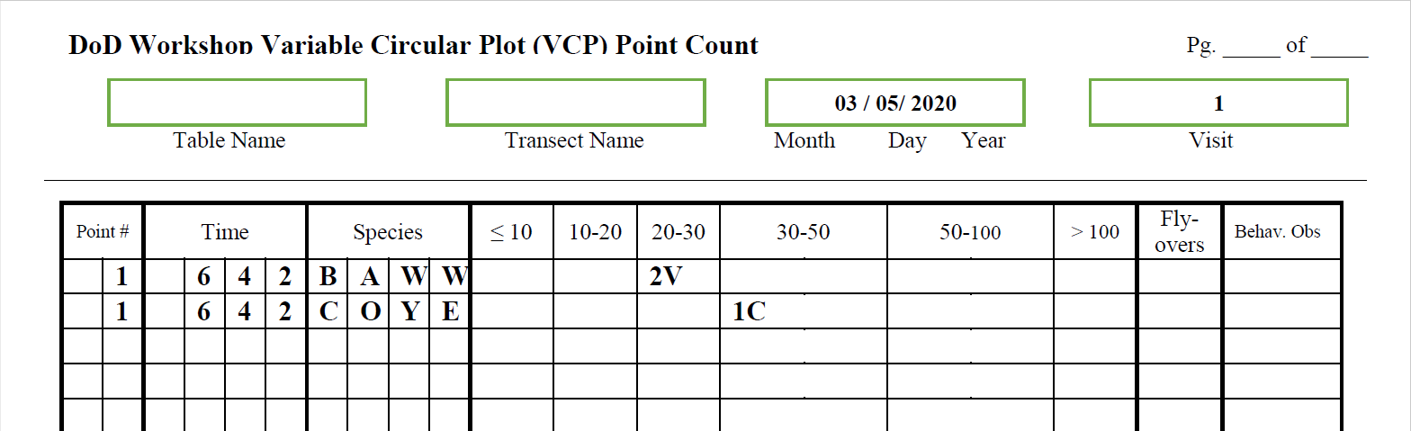

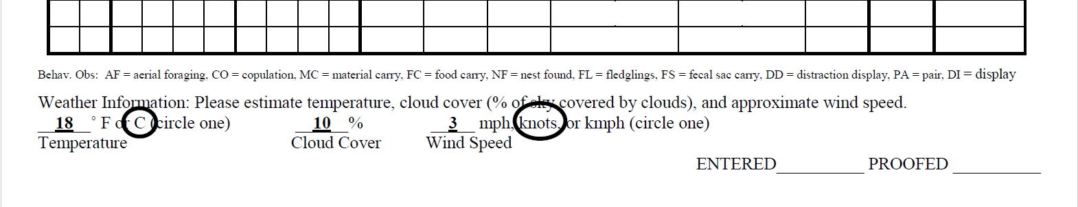

1. Open **Biologists** (<https://data.pointblue.org/science/biologists/>) and log in if needed.
2. Select the project on the left **DOD_DEMO**
3. Click on “**Point Count Surveys**” in the list on the right.
4. Find your Table and the Transect you created in Exercise 1 and click on it.
5. Under “Create a new visit”, select the protocols we added to the project:
   1. Observation Protocol: **VCP10_30**
   2. Site condition Protocol: **WEATHER**
   3. Click the **Start** button.
6. Fill out the screen using the information in the data sheet above:
   1. Date
   2. Visit
   3. Data sharing level - set to RAW and cannot be changed.
   4. Observer - you will see everyone in the project (all those in the class) can be selected.
   5. Start time - when did your 1 point survey start? Note the End Time automatically is populated
   6. Site conditions - look at the bottom of the survey form above for those data
   7. Observations -
      1. Search the species database - click to look up species by scientific name, common name, or 4 letter code
      2. Point - select the point you created. Notice the time is filled in.
      3. Species - we enter using 4 letter codes - IBP/AOU list + unknowns + common uncertain ids (<https://data.pointblue.org/science/biologists/php/sppsearch.php>). Also some mammals.
      4. Distance bins - enter Count and Detection together as collected on datasheet.
   8. Click **Save to Database** when finished.
      1. If you made any errors or forgot to fill in a required field, you will get a red message at the top of the screen. Go correct the error and click the Save to Database button again.
      2. If you are successful you should see a green message at the top of the screen.
   9. After saving to the database, you will be taken to the proofing page. You can review what entered to make sure you didn’t make mistakes.
      1. If you find a mistake, you can double click on the field and edit the field to correct.
      2. Click the Add more button if you forgot to add a line, such as an entire species, to the event.
   10. When you are satisfied, click the **Proofing Completed** button near the top of the page.
   11. Your survey is complete. You will see your survey in the list of surveys, and the Data Sharing Level is set to CLEAN.